Joe Biden welcomes topless activists to White House
The President welcomed LGBTQ Americans to the White House on Saturday but not everyone was happy about how it went down.
-Carla Mascarenhas, June 14, 2023, News.Com.Au
Joe Biden and first lady Jill Biden welcomed LGBTQ Americans to the White House on Saturday, but the move outraged military veterans after the Pride banner was raised next to the American flag.
About 1500 guests attended the event - some of them topless - where the president told them: “You are loved. You are heard. You are understood. And you belong.”
Amid adoring chants of “four more years” Mr Biden told the crowd that LGBTQ rights were a “top priority” both at home and abroad.
He touted a number of steps taken by his administration to protect civil rights and tied stricter protections against gun violence to protecting the LGBTQ community.
But Mr Biden admitted, “For all the progress we’ve made, we know challenges still remain.”
“When a person can be married in the morning but thrown out of a restaurant for being gay in the afternoon, something is still very wrong in America,” he said.
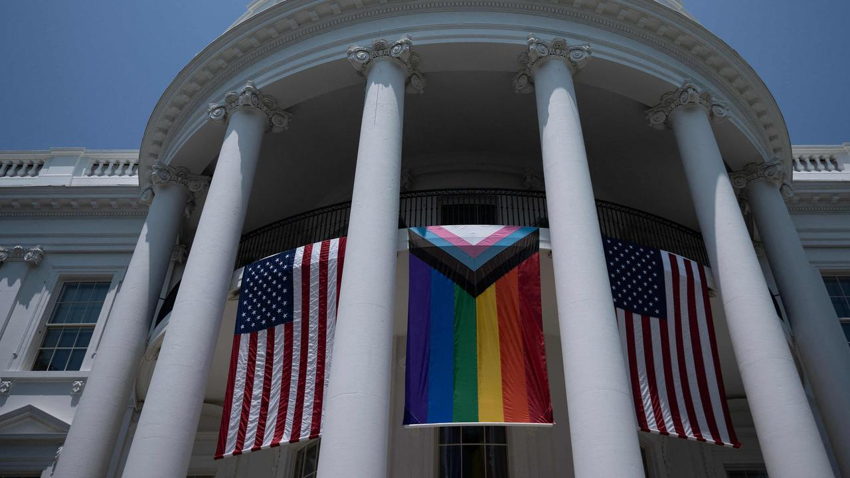
The White House held a Pride Month celebration on the South Lawn Saturday afternoon. Picture: AFP
But it was a decision to place the Pride banner at the centre of the White House balcony with one American flag to each side that angered some prominent military veterans.
Critics say the administration ran afoul of the US Flag Code, according to the New York Post, which states that the Stars and Stripes “should be at the centre and at the highest point of the group when a number of flags of States or localities or pennants of societies are grouped and displayed from staffs”.
“You would think the White House knows this,” Chad Robichaux, a Marine veteran who helped spearhead one of the largest civilian evacuation efforts from Afghanistan, wrote in a statement to the New York Post. “They do, they just don’t care.”
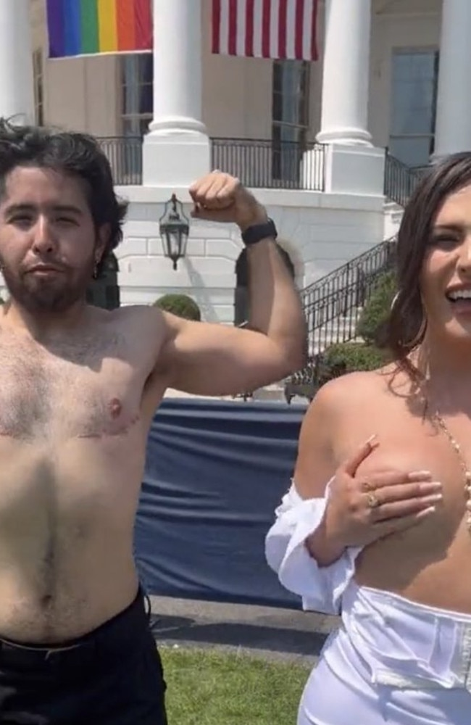
Some of the guests at the White House picnic to celebrate Pride month. Picture: Twitter / Libs of Tik Tok
“The American flag is the symbol of freedom and equality for every skin colour, every (legal) sexual preference, no social group needs another flag,” he added. “If every group could understand what the American flag truly represents, it would not be a divisive thing.”
Another veteran Marine Stuart Scheller who was relieved of his duties in August 2021 after calling out the botched withdrawal from Afghanistan also took offence.
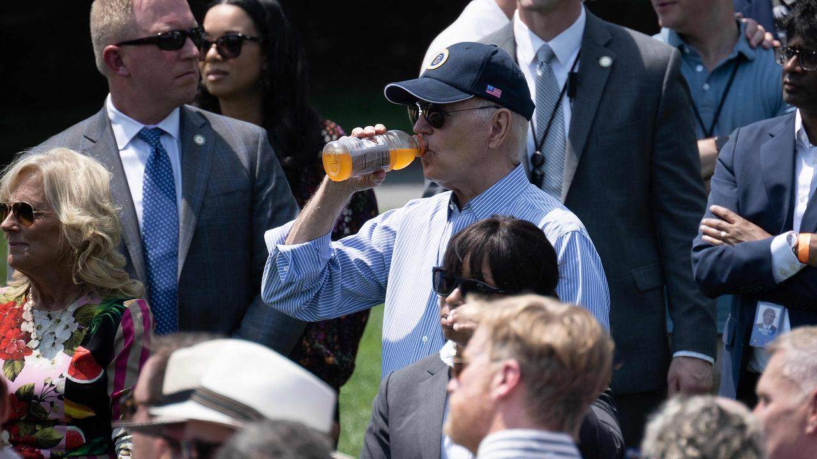
Jill and Joe Biden listen as Australian-US singer-songwriter Betty Who at the Pride event. Picture: AFP
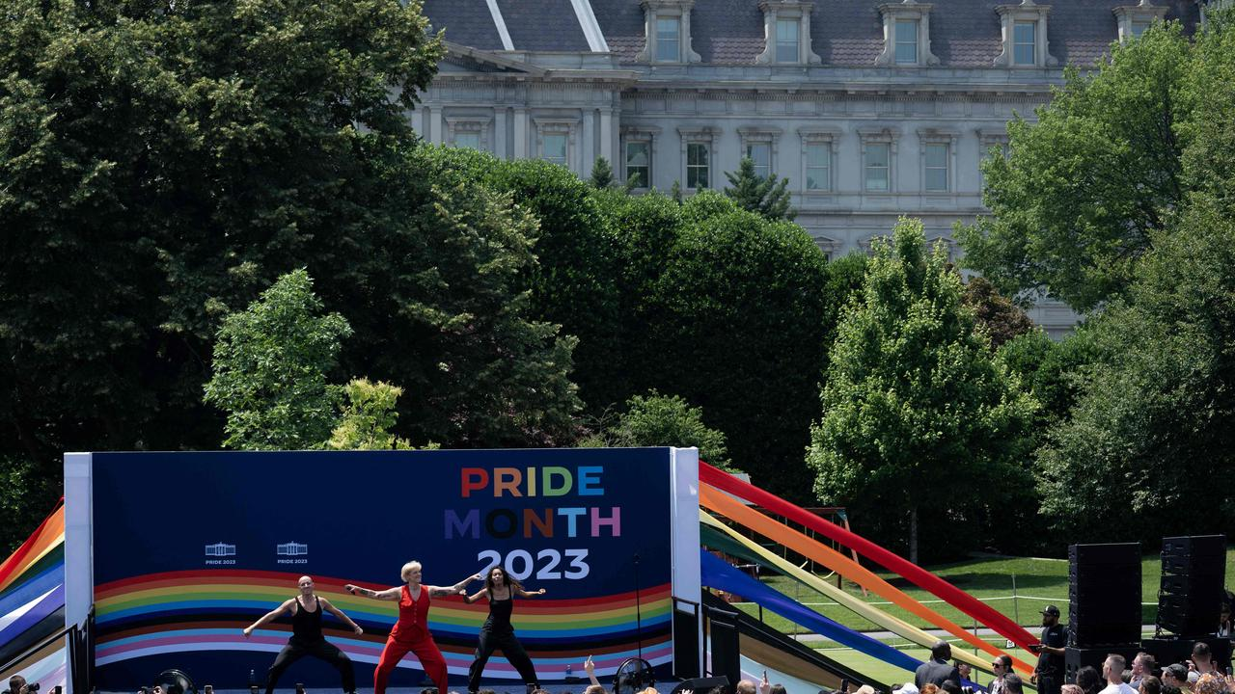
Australian-US singer-songwriter Betty Who performs during the celebration on the South Lawn of the White House. Picture: AFP
“I question the utility of my combat sacrifices when the Commander in Chief determines the American flag should acquiesce to another symbol of pride,” he said.
“Every veteran that has fought for this country and sacrificed so much is disgusted by the symbolism of the pride flag overtaking our nation’s flag at the White House,” said Victor Marx, a former Marine and founder of All Things Possible, a group that strives to aid those affected by trauma.
Army veteran Cory Mills decried the move as “shameful” and contended that “no flag should be flown at equal level to the American flag”.

